For Immediate Release

Diane Turton, Realtors

One of the

2021 NJ Family Business of the Year Award

Honorees

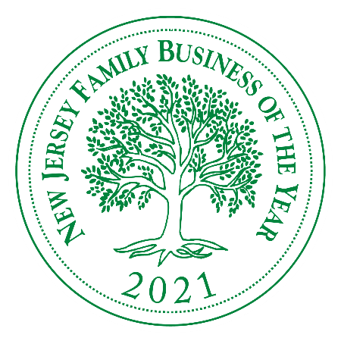 | 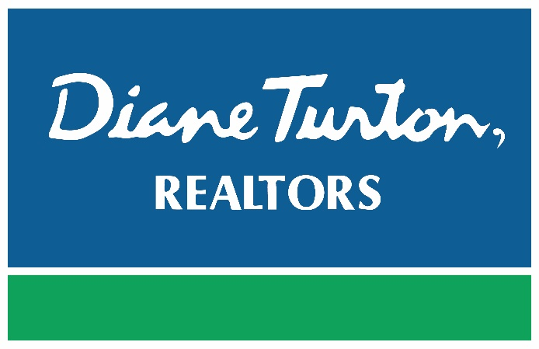

MADISON, N.J. (September 2021)– Fairleigh Dickinson University’s Rothman Institute of Innovation and Entrepreneurship is pleased to announce its 29th year of honoring family businesses in New Jersey.

This program recognizes the significant contributions to the economy and community made by extraordinary family businesses. This year, more than ever, their innovative strategies, personal achievements and business practices are vital for not only the NJ economy but for the survival of the legacy they have built. The challenges companies are facing this year are unprecedented and COVID19 took everyone by surprise. We would like to use this opportunity to highlight the struggles and successes these businesses have experienced and elevate their profile in the business community. Dr. Dale Caldwell, Executive Director of the Rothman Institute, states, “Family businesses form the foundation of the New Jersey economy. It is therefore essential that we support these businesses and celebrate their success.”

We are proud to announce the 2021 honorees:

Beacon Converter, Inc., Saddle Brook, NJ
Braunschweiger Jewelers, Morristown, NJ
Burke Motors Group, Cape May, NJ
Cranford Movie Theater and Drive-In, Cranford, NJ
Diane Turton, Realtors, Point Pleasant Beach, NJ
Estro Digital Communications, Westwood, NJ
Heritage’s Dairy Stores, Thorofare, NJ
JD Companies, Hackensack, NJ
McMahon Insurance Agency, Ocean City, NJ
Ravitz Family Markets, Cherry Hill, NJ
Triangle Manufacturing, Upper Saddle River, NJ

Sally Glick, MBA, Principal and Chief Growth Strategist at Sobel & Co. LLC, will team up with Dale as Master of Ceremonies. Sally has over 30 years’ experience working as a marketing consultant dealing with a wide range of CPA firms nationwide. “For several years, Sobel & Co has been a proud sponsor of the annual Fairleigh Dickinson University’s Family Business of the Year program. Since our inception more than 60 years ago, our firm has served the middle market, family-held business community. As such, it is an honor to partner with FDU to spotlight some of the best representatives of successful privately held companies across the state. This is the only event that recognizes New Jersey family businesses, and it is exciting to reward their efforts and celebrate their significant impact on the state’s economy and quality of life,” adds Rothman Institute’s Program Director, Susan Slavin.

This year, we are excited to welcome Cathy Choi, President of Bulbrite Industries based in Moonachie. Bulbrite is a 50-year-old lighting company with a rich family history. It was founded in New York City by a Korean immigrant, Andrew Choi, who was pursuing his American Dream.

We are so thankful to our sponsors that continue to support this program and look forward to celebrating on Wednesday, October 27, 2021 at the Glen Ridge Country Club.

About NJ Family Business of the Year Awards

The 2021 NJ Family Business of the Year Awards is sponsored by New Jersey Business Magazine, FDU’s Rothman Institute of Innovation & Entrepreneurship, the Glen Ridge Country Club, New Jersey Business & Industry Association, Sobel & Co., LLC, Lasso and C3Workplace.

Part of Silberman College of Business since 1989, the Rothman Institute of Innovation and Entrepreneurship supports, promotes and researches entrepreneurship with a special focus on family owned and veteran businesses. For more information on FDU’s Rothman Institute programs, please visit www.fdu.edu/rothman.

About Diane Turton, Realtors

Since 1985, the Diane Turton, Realtors name has earned renowned recognition as the premier real estate company in the markets that they serve. With 16 strategic Sales locations serving all of New Jersey, the Diane Turton brand is recognized worldwide in providing complete residential and commercial real estate ownership services and support. Diane Turton, Realtors caters to all real estate requirements, including title, insurance, referral and relocation services. The company is staffed with nearly 425 sales associates including a full-time management/support team. Led by President/Founder, Diane Turton for the past 36 years, Diane Turton, Realtors was founded on the following five core values: Trust, Communication, Service, Knowledge and Courtesy.

Experts in the markets they serve, Diane Turton, Realtors operates in close proximity to New York City, Philadelphia and Atlantic City. More information on the dynamics of Diane Turton, Realtors can be found by visiting the company website at www.dianeturton.com

