Diane Turton, Realtors
Nominated for
Prestigious World Diamond Award
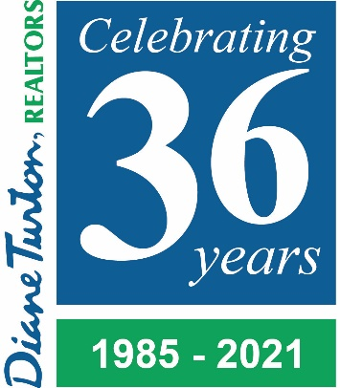

Point Pleasant Beach, NJ (May 12, 2021) – Diane Turton, Realtors is proud to announce it has been named a nominee for the Leading Real Estate Companies of the World® Diamond Award. Leading Real Estate Companies of the World (LeadingRE) is a community of more than 500 of the world’s market-leading independent residential brokerages from over 70 countries.

The Diamond Award is presented annually to a member company that has most actively participated in all of LeadingRE’s business offerings. Only 79 of the 550 real estate firms were nominated for this award. The winner will be announced during the Annual Awards Gala in Las Vegas on May 27th, 2021. The event attracts brokers, managers and relocation professionals from leading real estate brokerages worldwide.

“To be nominated for this award is a true honor to the hard work and dedication of our Managers, Agents and Staff,” said Diane Turton, President/Founder of Diane Turton, Realtors. “We share this nomination with some of the finest real estate brokerages in the industry – firms like ourselves that are progressive, engaged and committed to delivering outstanding service and support to their clients.”
As a member of Leading Real Estate Companies of the World®, Diane Turton, Realtors is affiliated with the finest real estate firms worldwide. This business relationship enables Diane Turton, Realtors to assist individuals relocating to virtually any community in the U.S. or abroad, with services including real estate assistance, and support.
For more information on Diane Turton, Realtors, visit www.dianeturton.com or call 877-887-8660.
About Leading Real Estate Companies of the World®
Leading Real Estate Companies of the World® (www.LeadingRE.com) is a selective global community of the highest quality independent residential real estate companies, with over 550 companies and 135,000 Sales Associates in over 70 countries. Network members generate over 1.1 million transactions annually. LeadingRE exists to make its members better by connecting them to opportunities and people around the globe, supporting them with an international referral network, professional development programs, unique events and connections to people and opportunities worldwide.

About Diane Turton, Realtors
Since 1985, the Diane Turton, Realtors name has earned renowned recognition as the premier real estate company in the markets that they serve. With 16 strategic locations serving all of New Jersey, the Diane Turton, Realtors brand is the recognized leader in providing complete residential and commercial real estate ownership services and support. Diane Turton, Realtors caters to all real estate requirements, including title, insurance, relocation and referral services. The company is staffed with 425 sales associates including a full-time management/support team. Led by President/Founder, Diane Turton for the past 36 years, Diane Turton, Realtors was founded on the following five core values: Trust, Communication, Service, Knowledge and Courtesy.
Experts in the markets they serve, Diane Turton, Realtors operates in close proximity to New York City and Philadelphia. More information on the dynamics of Diane Turton, Realtors can be found on the company website at www.dianeturton.com

