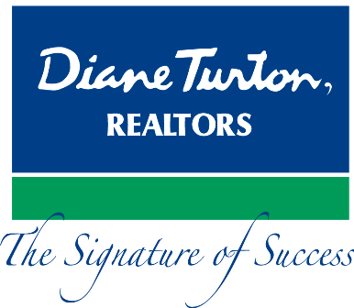
For Immediate Release
Contact: - Perry Beneduce - Office: 732-292-1400 - Email: pbeneduce@dianeturton.com

AGENT FROM DIANE TURTON, REALTORS
AWARDED SRS DESIGNATION

August 22, 2014 – Brian Homer of Diane Turton, Realtors, has been awarded the Seller Representative Specialist (SRS^{sm}) designation, the premier seller agency designation in the country. The SRS is conferred by the Council of Real Estate Brokerage Managers (CRB) and is an official credential of the National Association of REALTORS®. Brian joins an elite group of real estate professionals in North America who have earned the SRS^{sm} designation. All were required to successfully complete a comprehensive course in seller representation, pass a comprehensive exam and subscribe to the REALTOR® Code of Ethics.

SRS^{sm} is a wholly owned division of CRB and focuses specifically on representing the real estate seller. Founded in 1968, CRB is a not-for-profit affiliate of the National Association of REALTORS®. For more information about SRS you may contact SRS by telephone, 800-621-8738, by e-mail, CustomerService@SRSCouncil.com, or by visiting the SRS website, www.SRSCouncil.com.
Brian Homer is a member of the Diane Turton, Realtors Wall Office Team located at 2383 Route 34, Wall, NJ. Brian can be reached at Office: 732-292-1400, Cell: 732-580-2134 or bhomer@dianeturton.com.
About Diane Turton, Realtors
Since 1986, the Diane Turton, Realtors name has earned renowned recognition as the premier real estate company in the markets that they serve. With 16 strategic locations on the New Jersey shoreline, the Diane Turton brand is the recognized leader in providing complete residential and commercial real estate ownership services and support. Diane

Turton, Realtors caters to all real estate requirements, including mortgage, title, insurance and relocation services. The company is staffed with nearly 350 sales associates along with a full-time management/support team. Led by President/Founder, Diane Turton for the past 28 years, Diane Turton, Realtors was founded on the following five core values: Trust, Communication, Service, Knowledge and Courtesy.

Experts in the markets they serve, Diane Turton, Realtors operates in close proximity to New York City, Philadelphia and Atlantic City. More information on the dynamics of Diane Turton, Realtors can be found on the company website, www.dianeturton.com, or by calling the Diane Turton, Realtors Customer Service Centre at 1-877-388-7866.

.

