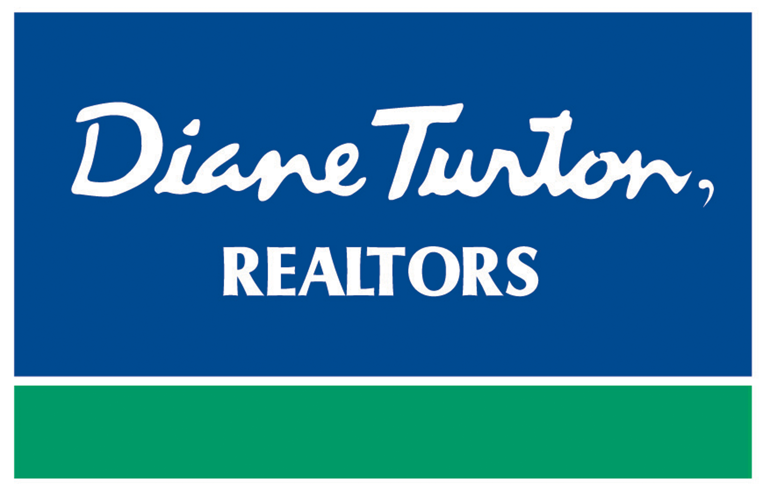
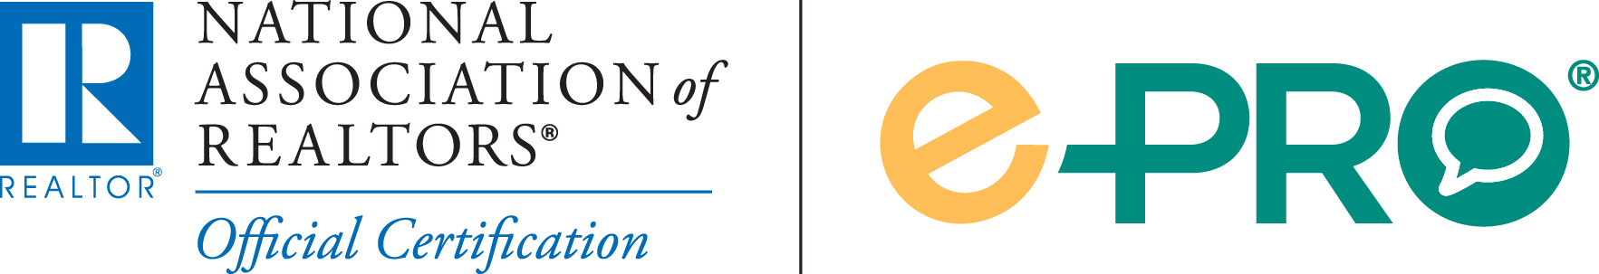

For Immediate Release
Contact: - Perry Beneduce - Office: 732-292-1400 - Email: pbeneduce@dianeturton.com
Agent from Diane Turton, Realtors
Earns e-PRO® Certification
August 13, 2014 – Edwin (Ed) O’Malley of Diane Turton, Realtors has successfully completed the e-PRO→ Certification Program and has been awarded the e-PRO® Certification, the official technology certification program offered by the NATIONAL ASSOCIATION OF REALTORS® (NAR).

Ed joins more than 30,000 real estate professionals who have earned NAR’s e-PRO® certification and dedicated time and effort towards learning how to use the latest social media technologies to create an online presence and reach today’s hyper-connected consumers.

Working together with the Social Media Marketing Institute (SMMI), NAR redesigned the e-PRO® curriculum to better meet the challenges of today’s real estate market. The new e-PRO® program expands an agent’s real estate technology skills and helps them connect with consumers online via social media, email marketing, and web site promotion.

“Today’s consumers are beginning their real estate search online,” said Ed of Diane Turton, Realtors. “With an increasing number of consumers turning to social media and online technology throughout their home search, it is essential for today’s agents to have the knowledge and training necessary to connect with these consumers online.”

Social media is still relatively new and evolving every day. Agents who earn e-PRO→ are dedicated to making the most of today's social media and technology to help consumers with their real estate needs, whatever they may be.
Ed O’Malley is a member of the Diane Turton, Realtors Bay Head Team located at 60 Bridge Avenue, Bay Head, NJ. For more information about e-PRO®, visit ePRONAR.com or contact Ed O’Malley of Diane Turton, Realtors at Office: 732.295.9700 x203 or Cell: 732.779.5088.
About Diane Turton, Realtors
Since 1986, the Diane Turton, Realtors name has earned renowned recognition as the premier real estate company in the markets that they serve. With 16 strategic locations on the New Jersey shoreline, the Diane Turton brand is the recognized leader in providing complete residential and commercial real estate ownership services and support. Diane

Turton, Realtors caters to all real estate requirements, including mortgage, title, insurance and relocation services. The company is staffed with nearly 350 sales associates along with a full-time management/support team. Led by President/Founder, Diane Turton for the past 28 years, Diane Turton, Realtors was founded on the following five core values: Trust, Communication, Service, Knowledge and Courtesy.

Experts in the markets they serve, Diane Turton, Realtors operates in close proximity to New York City, Philadelphia and Atlantic City. More information on the dynamics of Diane Turton, Realtors can be found on the company website, www.dianeturton.com, or by calling the Diane Turton, Realtors Customer Service Centre at 1-877-388-7866.

.

