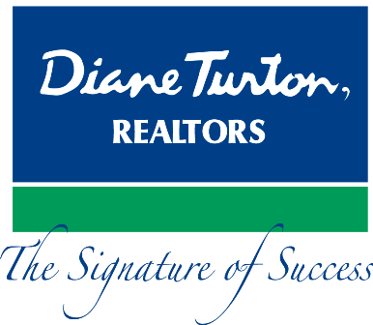
For Immediate Release
Contact: - Perry Beneduce - Office: 732-292-1400 - Email: pbeneduce@dianeturton.com

AGENTS FROM DIANE TURTON, REALTORS
ACHIEVE NATIONAL RECOGNITION

November 10, 2014 –Doris Baril, Louise Kelly-Decker, Kristen Lewis, Susan Miller and Cindy Napp, all real estate agents of Diane Turton, Realtors, have been awarded the Accredited Buyer’s Representation (ABR®) designation by the Real Estate Buyer’s Agent Council. (REBAC) of the NATIONAL ASSOCIATION OF REALTORS (NAR).
These agents join more than 30,000 real estate professionals in North America who have earned the ABR designation. All were required to successfully complete a comprehensive course in buyer representation and an elective course focusing on a buyer representation specialty, both in addition to submitting documentation verifying professional experience.
“I am very proud of these agents and their strong commitment to professional development,” said Diane Turton, President/Founder, Diane Turton, Realtors. “At Diane Turton, Realtors we encourage and fully support continuous training and education in order for our agents to best serve our customers.”
These agents are all based out of the Diane Turton, Realtors, Spring Lake Office located at 1216 Third Avenue, Spring Lake and can be reached at 732-449-4441.
About Diane Turton, Realtors
Since 1986, the Diane Turton, Realtors name has earned renowned recognition as the premier real estate company in the markets that they serve. With 16 strategic locations on the New Jersey shoreline, the Diane Turton brand is the recognized leader in providing complete residential and commercial real estate ownership services and support. Diane

Turton, Realtors caters to all real estate requirements, including mortgage, title, insurance and relocation services. The company is staffed with nearly 350 sales associates along with a full-time management/support team. Led by President/Founder, Diane Turton for the past 28 years, Diane Turton, Realtors was founded on the following five core values: Trust, Communication, Service, Knowledge and Courtesy.

Experts in the markets they serve, Diane Turton, Realtors operates in close proximity to New York City, Philadelphia and Atlantic City. More information on the dynamics of Diane Turton, Realtors can be found on the company website, www.dianeturton.com, or by calling the Diane Turton, Realtors Customer Service Centre at 1-877-388-7866.

ABR® (Accredited Buyer’s Representative) and ABRM (Accredited Buyer’s Representative Manager) are designations of
REBAC (Real Estate Buyer’s Agent Council) and THE NATIONAL ASSOCIATION OF REALTORS®

.

