For Immediate Release
Contact: - Perry Beneduce - Office: 732-292-1400 - Email: pbeneduce@dianeturton.com
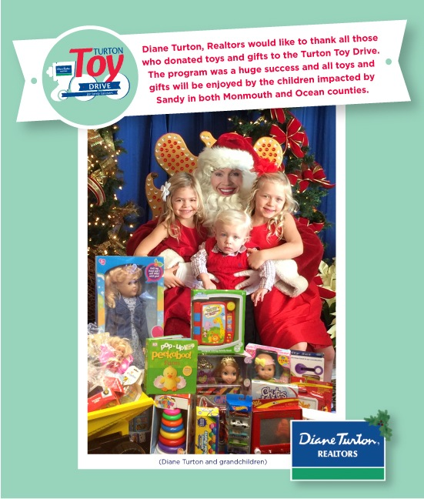

Diane Turton, Realtors
Turton Toy Drive for Sandy Survivors
Huge Success!

Again this holiday season, Diane Turton, Realtors joined forces with the Monmouth County Long Term Recovery Group (MCLTRG) and the Ocean County Long Term Recovery Group (OCLTRG) to launch Turton Toy Drive for Sandy Survivors, a toy and game drive benefiting the children impacted by Sandy in both Monmouth county and Ocean county.

The Turton Toy Drive was a complete success due to the generous donations from all the Managers, Agents and Staff at Diane Turton, Realtors and their business partners and clients.
The toys and games collected at the Diane Turton, Realtors Monmouth County offices are being distributed by the Monmouth County Long Term Recovery Group to Monmouth County families with children impacted by Hurricane Sandy. The toys and games collected at the Diane Turton, Realtors Ocean County offices are being distributed by the Ocean County Long Term Recovery Group to Ocean County families with children impacted by Hurricane Sandy.
For over 28 years, Diane Turton has delivered a message of hope to less fortunate children through the collection of gifts by her real estate agents for children in need during the Holiday Season. “Again this year we exceeded our collection expectations and were successful in making sure that the children and teenagers impacted by Hurricane Sandy have presents for Christmas”, said Diane Turton, President/Founder Diane Turton, Realtors. “These two non-profit organizations, MCLTRG & OCLTRG, have been very instrumental in helping New Jersey individuals impacted by Hurricane Sandy. I greatly admire their work and applaud their efforts”.

About Diane Turton, Realtors
Since 1986, the Diane Turton, Realtors name has earned renowned recognition as the premier real estate company in the markets that they serve. With 16 strategic locations on the New Jersey shoreline, the Diane Turton brand is the recognized leader in providing complete residential and commercial real estate ownership services and support. Diane Turton, Realtors caters to all real estate requirements, including mortgage, title, insurance and relocation services. The company is staffed with nearly 350 sales associates along with a full-time management/support team. Led by President/Founder, Diane Turton for the past 28 years, Diane Turton, Realtors was founded on the following five core values: Trust, Communication, Service, Knowledge and Courtesy.
Experts in the markets they serve, Diane Turton, Realtors operates in close proximity to New York City, Philadelphia and Atlantic City. More information on the dynamics of Diane Turton, Realtors can be found on the company website, www.dianeturton.com.

