For Immediate Release
Contact: - Perry Beneduce - Office: 732-292-1400 - Email: pbeneduce@dianeturton.com
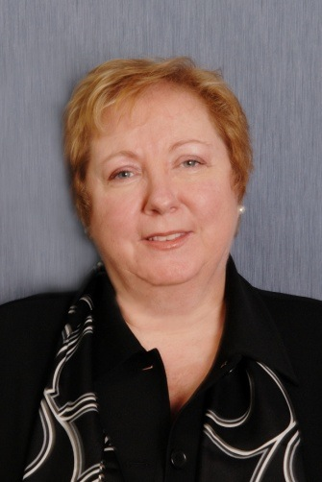

Dawn Fetherston of Diane Turton, Realtors
Presents at
Global Real Estate Event
In Las Vegas

Point Pleasant, New Jersey –February 23, 2015 – Dawn Fetherston, Relocation-Referral Director with Diane Turton, Realtors was a speaker at the Leading Real Estate Companies of the World® Annual Conference, which took place February 11-13 at the Wynn in Las Vegas. The event was part of the Leading Real Estate Companies of the World® (LeadingRE) Conference Week, which attracted a prestigious audience of over 2,000 real estate professionals from more than 20 countries.

The event was open exclusively to brokers, managers and relocation professionals affiliated with LeadingRE, a global network of 500+ market-leading real estate firms representing more home sales than any other real estate network. The conference gave attendees the opportunity to explore timely issues impacting the real estate market and address ways to best meet the needs of today’s buyers and sellers.

Dawn Fetherston presented information on Generating Referrals, sharing insights on how best to turning your business into a referral-generating machine.

Fetherston was among a notable line-up of speakers, which included keynote speaker Rudy Giuliani, celebrated by many as “Mayor of the World,” whose motivational presentation focused on “Principled Leadership in the Face of Change and Crisis.” Other featured speakers included Peter Sheahan, a best-selling author known for inspiring innovative business thinking and creating lasting behavior change; Travis Robertson, a leading expert on working with the next generation of home buyers and sellers; Ron White, one of the foremost memory training experts in the world; and Stefan Swanepoel, an analyst known for research on the changes and trends impacting the real estate industry.

Diane Turton, Realtors is an active member of Leading Real Estate Companies of the World® (www.LeadingRE.com), the largest network of premier locally-branded firms in more than 50 countries producing over one million annual home sale transactions. LeadingRE provides its affiliates with an extensive range of brokerage services, which include lead generation, cross-market referrals, branding support, luxury marketing, online exposure, technology systems, and industry-leading professional development.

About Diane Turton, Realtors
Since 1985, the Diane Turton, Realtors name has earned renowned recognition as the premier real estate company in the markets that they serve. With 15 strategic locations on the New Jersey shoreline, the Diane Turton brand is the recognized leader in providing complete residential and commercial real estate ownership services and support. Diane Turton, Realtors caters to all real estate requirements, including mortgage, title, insurance and relocation services. The company is staffed with nearly 350 sales associates along with a full-time management/support team. Led by President/Founder, Diane Turton for the past 30 years, Diane Turton, Realtors was founded on the following five core values: Trust, Communication, Service, Knowledge and Courtesy.
Experts in the markets they serve, Diane Turton, Realtors operates in close proximity to New York City, Philadelphia and Atlantic City. More information on the dynamics of Diane Turton, Realtors can be found on the company website at www.dianeturton.com.

About Leading Real Estate Companies of the World®
Leading Real Estate Companies of the World® (www.LeadingRE.com) is the largest network of top independent local and regional brand-name brokerage firms in the residential sector of real estate. The 500 firms affiliated with Leading Real Estate Companies of the World® are represented by 3,500 offices and 120,000 associates in more than 50 countries worldwide. The organization's leadership is demonstrated by the fact that its affiliates comprise 15 of the top 25 real estate companies in the country. Collectively, LeadingRE affiliates produced home sales valued at $314 billion in the U.S. in 2013. In addition, LeadingRE locally-branded affiliates hold the Number One position in sales in 39% of the top 108 markets in the U.S., more than any national franchise organizations.

