For Immediate Release
Contact: - Perry Beneduce - Office: 732-292-1400 - Email: pbeneduce@dianeturton.com

Diane Turton, Realtors Attend
13th Annual Luxury Real Estate Spring Retreat in Costa Rica
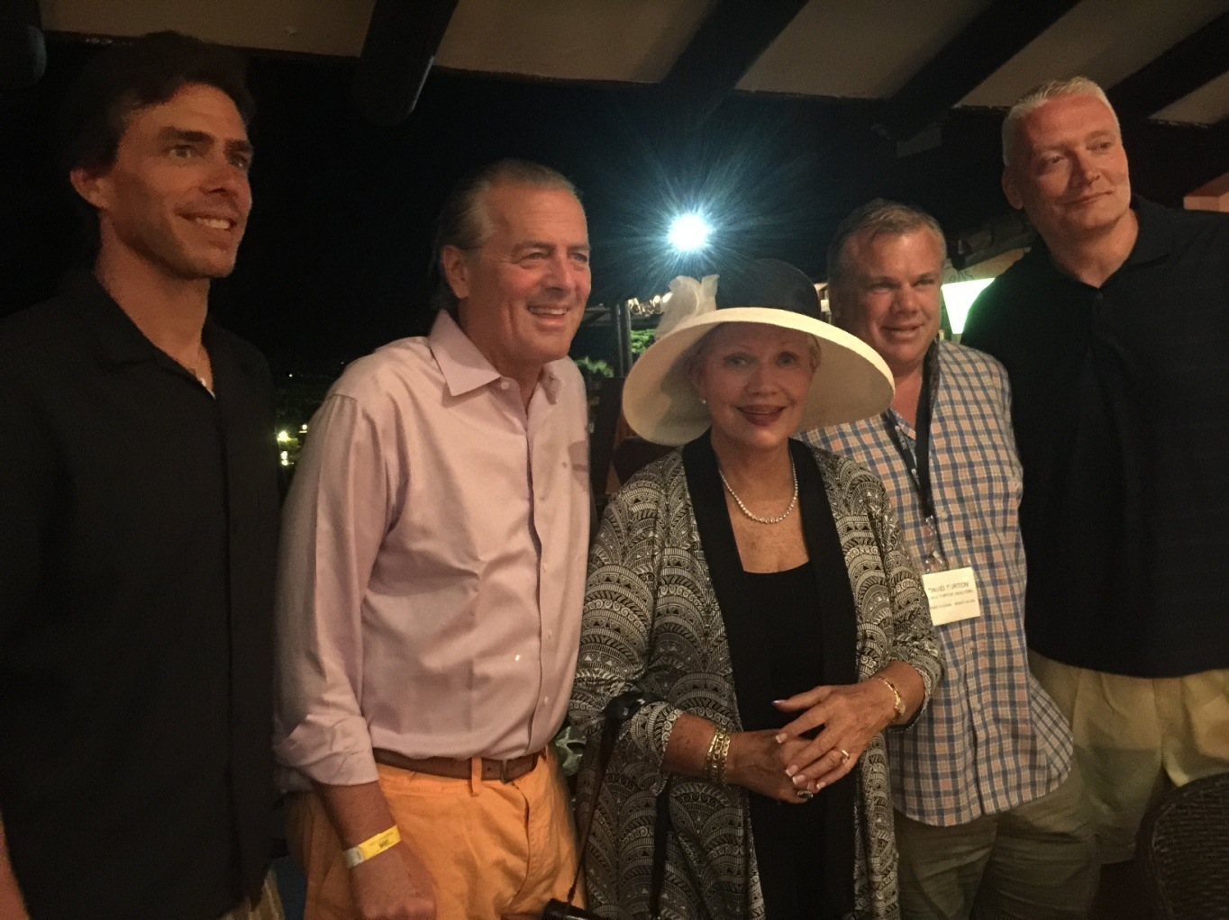
Point Pleasant, New Jersey –April 21, 2015 – Diane Turton, President and Founder of Diane Turton, Realtors, participated in the The 13th Annual Luxury Real Estate Spring Retreat held Tuesday, April 7th through Friday, April 10th at Los Sueños Marriott Ocean & Golf Resort in Herradura, Costa Rica. Also attending from Diane Turton, Realtors was Scott McGrory, David Turton and Jason Turton.
Throughout the Spring Retreat, Luxury Real Estate members participated on panels and group discussions that explored topics including the challenges and triumphs of changing brands, utilizing technology for marketing luxury properties, building an effective database, keys to running a successful luxury real estate business and the best practices of working in today’s competitive high-end market. Featured Speakers, Pamela Aden and Mary Anne Aden of Aden Research, S.A, shared insight on the global financial markets and how they affect real estate cycles today. Several networking activities provided attendees with the opportunity to connect with members from all across the world.
This event, hosted by Who’s Who in Luxury Real Estate and LuxuryRealEstate.com Chairman/Publisher, John Brian Losh, is one of four annual invitation-only networking events that bring together the world’s most prominent high-end real estate brokers. John Brian Losh shares that, “We are pleased at the great success of this event as it is the first time we have convened in Central America. Choosing a well-rounded array of locations for our Luxury Real Estate events benefits our members immensely by ensuring the opportunity for them to continuously create and strengthen connections in international markets. Assembling in Costa Rica not only opened up a place for constructive dialog between these elite brokers, but also provided them with the venue to network in a more relaxed environment and get to know one another on a deeper level. Our local representatives from 2Costa Rica Real Estate went above and beyond to show conference attendees the beauty of Costa Rica."

About Diane Turton, Realtors
Since 1985, the Diane Turton, Realtors name has earned renowned recognition as the premier real estate company in the markets that they serve. With 15 strategic locations on the New Jersey shoreline, the Diane Turton brand is the recognized leader in providing complete residential and commercial real estate ownership services and support. Diane Turton, Realtors caters to all real estate requirements, including mortgage, title, insurance and relocation services. The company is staffed with nearly 350 sales associates along with a full-time management/support team. Led by President/Founder, Diane Turton for the past 30 years, Diane Turton, Realtors was founded on the following five core values: Trust, Communication, Service, Knowledge and Courtesy.
Experts in the markets they serve, Diane Turton, Realtors operates in close proximity to New York City, Philadelphia and Atlantic City. More information on the dynamics of Diane Turton, Realtors can be found on the company website at www.dianeturton.com.

About LuxuryRealEstate.com
LuxuryRealEstate.com, a Webby Award Honoree, has been voted ‘Best of the Web’ by Forbes magazine multiple times, praised by the International Herald Tribune, Town & Country, The Wall Street Journal and has been ranked ‘Best Website’ by consumer surveys. Since its debut in 1995, LuxuryRealEstate.com has remained the #1 portal for luxury properties on the internet and has several times more $1,000,000+ content of any near-peer.
Known in the industry since 1986 as the Who’s Who in Luxury Real Estate network, a global collection of the finest luxury real estate brokers in the world, this group of more than 130,000 professionals in more than 60 countries collectively sells in excess of $190 billion of real estate annually. Members are selected by Chairman/Publisher John Brian Losh, one of REALTOR Magazine's 25 Most Influential People in Real Estate and broker of fine properties and estates through his Seattle-based brokerage firm, Ewing & Clark, Inc. Luxury Real Estate has been recognized by the Webby Awards, has received “Best of the Web” by Forbes Magazine, honored with an ADDY Award for Excellence in Web Design, deemed “Best Website” by consumer surveys, ranked in the Inc. 5000 List, noted as one of the 100 Fastest Growing Private Companies by Puget Sound Business Journal, and recognized by the Maggie Awards.

