For Immediate Release
Contact: - Perry Beneduce - Office: 732-292-1400 - Email: pbeneduce@dianeturton.com

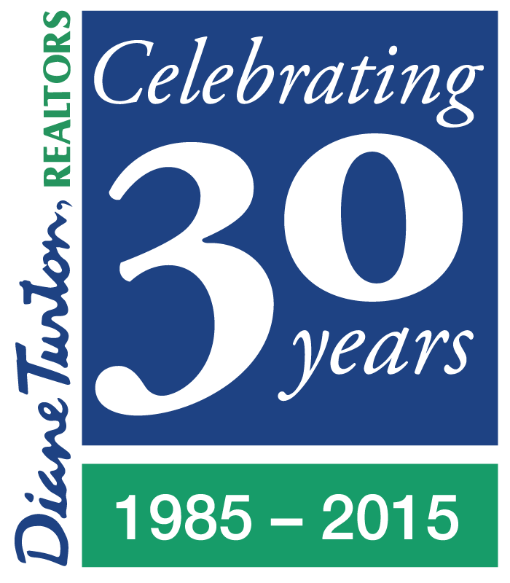 | Diane Turton, Realtors  Ranks as One of Nation's  Top-Producing Brokerage Firms  In RISMedia's 2015 Power Broker Report | 

(RISMedia-Norwalk, CT) - Diane Turton, Realtors, headquartered in Point Pleasant Beach, New Jersey recently announced its ranking as one of the Top 500 real estate firms in the United States in sales volume and its ranking as one of the Top 8 real estate firms in New Jersey in sales volume according to RISMedia's 27th Annual Power Broker Report.
This year's Power Broker Report is based on responses to RISMedia's 2015 Power Broker Survey, distributed in early January. More than 1,000 real estate firms from across the country completed the Power Broker Survey, reporting a collective 3,203,736 closed residential transactions in 2014, accounting for a total $973,976,005,312 in sales volume.
Now in its 27th year, the Power Broker Report has long honored the incredible business feats of remarkable real estate leaders-and brokerage firms-who continue to shape our industry. Each April, RISMedia's Real Estate magazine highlights the Top 500 Power Broker firms according to sales volume and transactions.
RISMedia President & CEO John Featherston congratulated Diane Turton, Realtors for their prestigious ranking in this year's Power Broker Report. "The firms represented are the nation's most elite brokerage firms serving literally millions of consumers with their real estate needs," Featherston said. "2014 was a growth year for many real estate firms across the country, as low inventory created a ripe environment for home sellers and move-up buyers, and continued low interest rates and rising rents enticed more new buyers to take action. As market dynamics continue to fluctuate, today's more knowledgeable, more tech-savvy real estate consumers will look to proven real estate firms and their agents to help guide them toward the best real estate decision. Being ranked in the Power Broker Report validates your firm's reputation as a trusted resource for today's homebuyers and sellers."
RISMedia's Annual Power Broker Report ranks firms by closed transactions and sales volume for the prior year. RISMedia's 27th Annual Power Broker Report & Survey is based on results garnered from a survey distributed via email. The survey ranks residential real estate brokerage firms according to closed transaction numbers and closed sales volume for the year 2014. All sales and transaction data is submitted directly by brokerage firms and verified by the firm's financial executives, outside accounting firms and /or corporate franchise headquarters.
“Our company’s success is driven by talented people who have a passion for real estate and share the same mindset, values and vision all focused on the customer”, said Diane Turton, President/Founder of Diane Turton, Realtors. “We have the best team of real estate agents and managers. We have the best training and marketing. And we are proud of our 30 years of sustained performance as the real estate company of choice at the Jersey Shore and we look forward to our continued success”, said Diane.

About Diane Turton, Realtors
Since 1985, the Diane Turton, Realtors name has earned renowned recognition as the premier real estate company in the markets that they serve. With 15 strategic locations on the New Jersey shoreline, the Diane Turton brand is the recognized leader in providing complete residential and commercial real estate ownership services and support. Diane Turton, Realtors caters to all real estate requirements, including mortgage, title, insurance and relocation services. The company is staffed with nearly 350 sales associates along with a full-time management/support team. Led by President/Founder, Diane Turton for the past 30 years, Diane Turton, Realtors was founded on the following five core values: Trust, Communication, Service, Knowledge and Courtesy.
Experts in the markets they serve, Diane Turton, Realtors operates in close proximity to New York City, Philadelphia and Atlantic City. More information on the dynamics of Diane Turton, Realtors can be found on the company website at www.dianeturton.com.

