For Immediate Release
Contact: - Perry Beneduce - Office: 732-292-1400 - Email: pbeneduce@dianeturton.com

Diane Turton, Realtors Bay Head Office

Returns to Their

Original Office Location in Bay Head

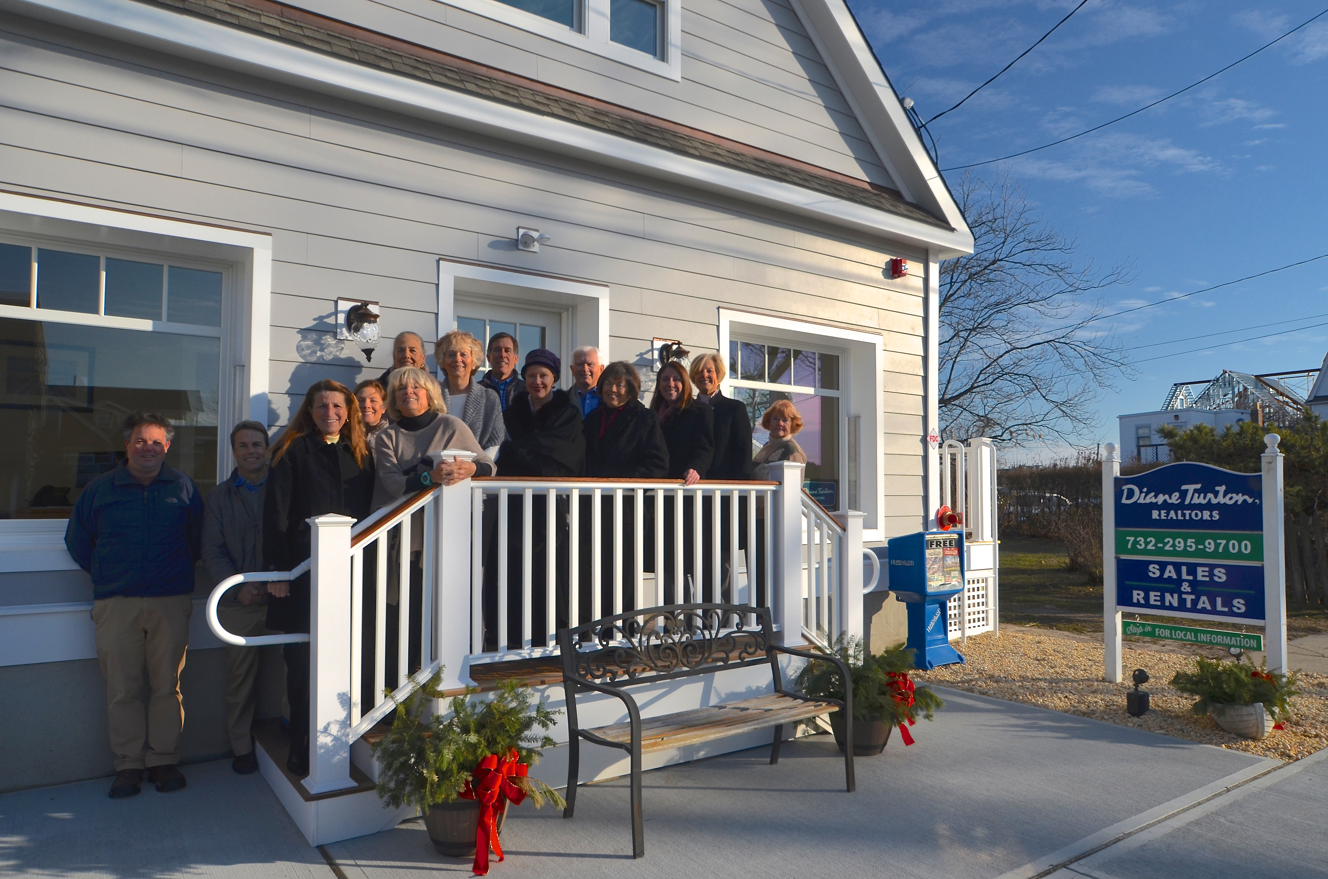

Point Pleasant, New Jersey –January 21, 2016 –Diane and Bruce Turton, Founders of Diane Turton, Realtors, are proud to announce the return of their Bay Head Real Estate Office Team to their original location in Bay Head at 88 Bridge Avenue.
Since Hurricane Sandy destroyed the Diane Turton, Realtors Bay Head Office at 88 Bridge Avenue, the Bay Head team of agents has been working in a temporary location at 60 Bridge Avenue in Bay Head. Although relocated to a temporary facility while reconstruction of their Sandy destroyed office occurred, the Diane Turton, Realtors Bay Head team continued to provide superior real estate service and support to the Jersey Shore community. Their business performance was second to none for 2015 as they were rated number one in Closed Sales in Bay Head for 2015 (Based on Monmouth MLS Market Penetration Report by Offices, for 1/1/2015 thru 12/31/2015).
“We were committed to rebuilding our Bay Head Office on the historic site we had occupied for over 30 years”, said Diane Turton, President/Founder of Diane Turton, Realtors. “The new building includes state of the art construction, open workspaces, greater energy efficiency, meeting areas for clients and partners and the latest in technology for best serving our clients”, said Diane.
A grand opening celebration is planned for the Spring of this year. The Bay Head Office is open 9 am to 5 pm seven days a week. The Diane Turton, Realtors Bay Head office location at 88 Bridge Avenue is easily found via Google Maps or any GPS tool or application. For more precise directions, you may call 732.295.9700 or visit: http://www.dianeturton.com/offices.php?oid=3

About Diane Turton, Realtors
Since 1985, the Diane Turton, Realtors name has earned renowned recognition as the premier real estate company in the markets that they serve. With 15 strategic locations on the New Jersey shoreline, the Diane Turton brand is the recognized leader in providing complete residential and commercial real estate ownership services and support. Diane Turton, Realtors caters to all real estate requirements, including mortgage, title, insurance and relocation services. The company is staffed with nearly 350 sales associates along with a full-time management/support team. Led by President/Founder, Diane Turton for the past 30 years, Diane Turton, Realtors was founded on the following five core values: Trust, Communication, Service, Knowledge and Courtesy.
Experts in the markets they serve, Diane Turton, Realtors operates in close proximity to New York City, Philadelphia and Atlantic City. More information on the dynamics of Diane Turton, Realtors can be found on the company website at www.dianeturton.com.

