For Immediate Release
Contact: - Perry Beneduce - Office: 732-292-1400 - Email: pbeneduce@dianeturton.com

Diane Turton, Realtors Attend the

21st Annual Luxury Real Estate Fall Conference

in Aspen, Colorado

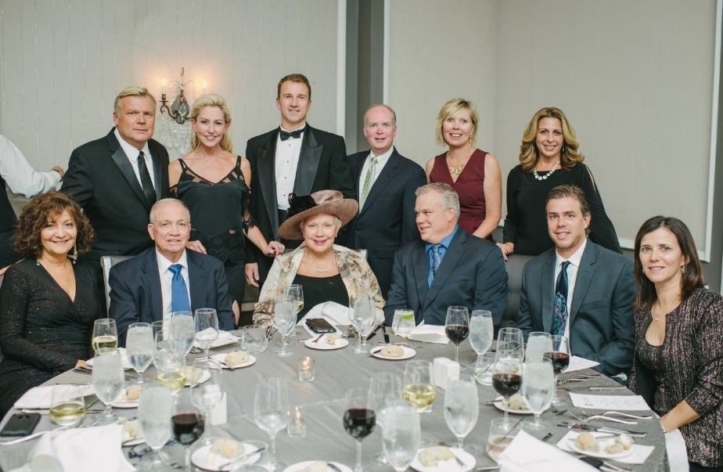

Point Pleasant Beach, NJ USA – Members of the Who’s Who in Luxury Real Estate network convened in Aspen, Colorado from Tuesday, September 27th through Friday, September 30th to celebrate thirty years as the leading luxury real estate network in the world.
Diane and Bruce Turton, Presidents/Founders, Diane Turton, Realtors and the following members of Diane Turton, Realtors attended the event: Perry Beneduce, Dale Bisgrove, Denise Bousanti, Laurie Enoch, Maryanne Roberto, Glenn Roth, Janie Ruocco, Colleen Tobin, David Turton and Jason Turton.
The 21st Annual Luxury Real Estate Fall Conference was a huge success, bringing members from across the globe together to share their knowledge and connect with fellow luxury professionals.
Keynote speakers included Dirk Zeller of Real Estate Champions, who shared strategies for creating a masterpiece listing presentation and key insights into how to market luxury listings. A highlight of the event was the expert panel discussions led by prominent members of the Who’s Who in Luxury Real Estate network. Diane Turton, President/Founder of Diane Turton, Realtors, was one of the three “Industry Legend” panelists who discussed “Lessons Learned from 30+ Years in Real Estate”.
The 21st Annual Luxury Real Estate Fall Conference is hosted by Who’s Who in Luxury Real Estate Chairman/Publisher, John Brian Losh, and is one of four annual invitation-only events that bring together the most prominent luxury brokerages from across the globe to discuss current real estate trends.

About Diane Turton, Realtors
Since 1985, the Diane Turton, Realtors name has earned renowned recognition as the premier real estate company in the markets that they serve. With 15 strategic locations on the New Jersey shoreline, the Diane Turton brand is the recognized leader in providing complete residential and commercial real estate ownership services and support. Diane Turton, Realtors caters to all real estate requirements, including title, insurance, relocation and referral services. The company is staffed with nearly 350 sales associates along with a full-time management/support team. Led by President/Founder, Diane Turton for the past 31 years, Diane Turton, Realtors was founded on the following five core values: Trust, Communication, Service, Knowledge and Courtesy.
Experts in the markets they serve, Diane Turton, Realtors operates in close proximity to New York City, Philadelphia and Atlantic City. More information on the dynamics of Diane Turton, Realtors can be found on the company website at www.dianeturton.com.

About LuxuryRealEstate.com
LuxuryRealEstate.com, frequently ranked ‘Best Website’ in consumer and industry surveys, has been recognized for excellence by the WMA Awards and the Webby Awards and has been voted ‘Best of the Web’ by Forbes magazine multiple times. Since its debut in 1995, LuxuryRealEstate.com has remained the #1 portal for luxury properties on the internet and has several times more $1,000,000+ content of any near-peer.
Known in the industry since 1986 as the Who’s Who in Luxury Real Estate network, a global collection of the finest luxury real estate brokers in the world, this group of more than 130,000 professionals with properties in more than 70 countries, collectively sells in excess of $190 billion of real estate annually. Members are selected by Chairman/Publisher John Brian Losh, one of REALTOR Magazine’s 25 Most Influential People in Real Estate and broker of fine properties through his Seattle-based brokerage firm, Ewing & Clark, Inc.
The company has also been recognized by the Maggie Awards, received an ADDY Award for excellence in Web Design, ranked in the Inc. 5000 List and named as one of the 100 Fastest Growing Private Companies by the Puget Sound Business Journal.

